Electrical Project Specification

Project Name: | On-Board Controller V1.1  (OBC)
Document Rev: | 09
Prepared by: | Ethan Nixon
Date: | 2025-06-09

Document Revisions
Revision | Date | Change(s)
01 | 2022/10/11 | Initial Release
02 | 2022/10/26 | Updating number of fans and block diagram
03 | 2022/11/09 | Updating PCB Stack-up
04 | 2022/11/10 | Adding new requirements and specifications
05 | 2022/03/07 | Adding Teesny pinout and I2C addresses
06 | 2023/12/19 | Updated block diagram and teensy pinout and added I2C addresses for I2C MUX and fan controller.
07 | 2024/06/16 | Updated number of fans
08 | 2025/06/06 | Updated board information for V1.1 version
09 | 2025/06/09 | Updated teensy pinout and servos I2C address

Table of Contents
Document Revisions 1
Table of Tables 3
Table of Figures 3
0.0 Conventions, Terms, & Reference Documents 3
0.1 Conventions 4
0.2 Terms & Definitions 4
0.3 Reference Documents 4
1.0 Description 4
1.1 Dependencies 4
2.0 Requirements & Constraints 4
3.0 Performance Specifications 5
4.0 PCB Layout 5
5.0 Mechanical Interfaces 6
6.0 Detailed Description (Theory of Operation) 6
6.1 Teensy Pinout 7
6.2 I2C Addressing 8

Table of Tables
Table 1: Reference documents 4
Table 2: Requirements & constraints 5
Table 3: Performance specifications 5
Table 4: PCB parameters 6
Table 5: PCB layer stack-up 6

Table of Figures
Figure 1: OBC Block Diagram 7

0.0 Conventions, Terms, & Reference Documents

0.1 Conventions
"Must" is used to indicate a mandatory requirement.

"Should" is used to indicate an additional nice to have.

"May" is used to indicate an option.

0.2 Terms & Definitions
OBC: On-Board Controller
TSB: Temperature Sensor Board

0.3 Reference Documents
Table 1: Reference documents
RD# | Document | Link
RD1 | Temperature Sensor Boards | TSB

1.0 Description
OBC is the main communication hub for all subassemblies in the V2 rover. All communication inside the rover will happen using CAN. OBC will use a Teensy 4.1 as the main microcontroller that will be programmed by the software team using MicroROS. OBC will contain GPS and LoRa modules, will power and monitor 3 fans and status/error LEDs, as well as gather temperature data from the temperature sensor boards (RD1). Additionally, it will also have an IMU chip on-board, while also allowing for the use of an external one. It will use ethernet protocol to communicate any necessary data to the Jetson AGX Orin.

1.1 Dependencies
OBC depends on the following systems for operation:
- 12V power from VIPER
- Ethernet connectivity to Jetson

2.0 Requirements & Constraints
Table 2: Requirements & constraints
Requirement ID | Description | Status
OBC-REQ-01 | OBC should be powered using 12V | MET
OBC-REQ-02 | OBC must contain a Teensy 4.1 as the main microcontroller | MET
OBC-REQ-03 | OBC must communicate with the Jetson T AGX Orin via ethernet | MET
OBC-REQ-04 | OBC must contain LoRa and GPS modules | MET
OBC-REQ-05 | OBC must have separate power for RF (LoRa, GPS) sections of the board | MET
OBC-REQ-06 | OBC must have CAN, SPI and I2C buses | MET
OBC-REQ-07 | OBC must contain an onboard IMU | MET
OBC-REQ-08 | OBC must be able to connect to external IMU | MET
OBC-REQ-09 | OBC must power and control Status LEDs | MET
OBC-REQ-10 | OBC must power and control the error lights | MET
OBC-REQ-11 | OBC must power and communicate with the Temperature Sensors | MET
OBC-REQ-12 | OBC must power, control and monitor 3 fans | MET
OBC-REQ-13 | OBC should allow for the use of up to 6 fans | MET
OBC-REQ-14 | OBC must always keep the GPS powered | MET
OBC-REQ-15 | OBC must be vertically mounted board | MET
OBC-REQ-16 | OBC must provide access to the SD card on the Teensy 4.1 | NOT NEEDED

3.0 Performance Specifications
Table 3: Performance specifications
Specification ID | Parameter | Min. | Nom. | Max. | Unit
OBC-SPEC-01 | Input Voltage | 11.8 | 12 | 12.2 | V
OBC-SPEC-02 | Input Current |  | 10.73 |  | A
OBC-SPEC-03 | I2C Bus Speed | 100 |  | 400 | kHz
OBC-SPEC-04 | SPI Bus Speed | 1 |  | 16 | MHz
OBC-SPEC-05 | Ethernet Speed | 1 |  | 10 | Mbps
OBC-SPEC-10 | PWM Frequency | 3.611 |  | 4.482 | kHz

4.0 PCB Layout
Table 4: PCB parameters
Parameter | Value | Unit
Number of Layers | 4 | -
PCB Thickness | 1.6 | mm
Vendor | JLCPCB | -

Table 5: PCB layer stack-up
Layer # | Copper Weight (oz) | Type
1 | 1 | Signal
2 | 0.5 | Ground
3 | 0.5 | Power
4 | 1 | Signal/Ground

5.0 Mechanical Interfaces
OBC will have an I/O bracket to allow for easy connection to its external modules. It will be mounted vertically to allow for the I/O bracket to be implemented properly.
OBC will power and control the status and error LEDs. These must be visible and properly weatherproofed.

6.0 Detailed Description (Theory of Operation)
Figure 1: OBC Block Diagram

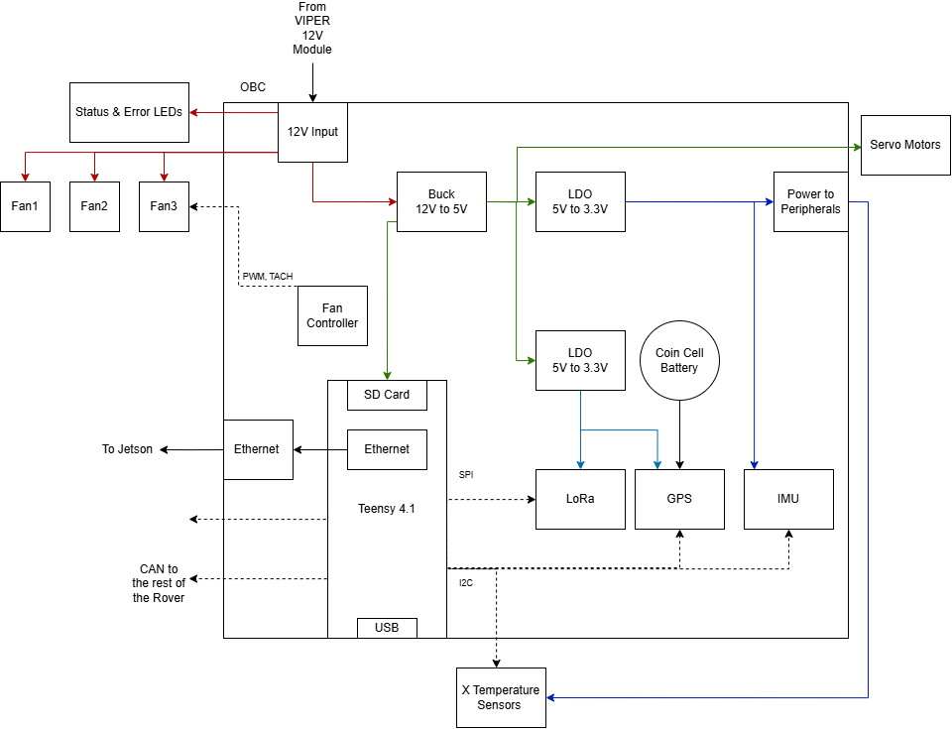

OBC will be powered via 12V from the VIPER modules.
The Teensy 4.1 is the main microcontroller used, which allows for the implementation of CAN, I2C, and SPI interfaces. It also allows for the use of ethernet which will be used to communicate necessary data to the Jetson, and SD card which can store any necessary data.
All subassemblies in the rover will be communicating via CAN. Therefore, OBC will contain a CAN bus that will deliver and receive data to and from other boards such as VIPER, BATMAN, MCS, RAD and SMRCC.
OBC will be responsible for powering, controlling, and monitoring the Fans & Temperature Sensors. It will be powering the fans using the 12V rail and controlling them through the use of Fan Controller ICs. It will be powering the Temperature Sensors using the 3.3V rail and gathering temperature data by using I2C.
OBC will control the status and error LEDs. There will be three lights to indicate the status of the rover:
- Red: autonomous operation
- Blue: teleoperation
- Flashing Green: successful arrival at a post or passage through a gate
OBC will have a yellow error LED which will communicate any errors when received from other boards/subassemblies in the rover.
OBC will also contain LoRa and GPS modules. The GPS module contains I2C and UART interfaces whereas the LoRa module contains only SPI. Since they are RF modules, they will have their own power source. The GPS sensor must always be on as to not lose its data, therefore it will always be powered using a coin cell battery.
The EEPROM chip will be programmed to store the CAN address of OBC.
There is an onboard IMU used to determine the rover acceleration, tilt, etc. at any point in time. It will also allow for the connection to an external one.
OBC powers and controls servo motors off the 5V rail to be able to change the on-rover camera’s angle during site tasks.
Additional headers have been broken out for sensors and miscellaneous pins.

6.1 Teensy Pinout
I/O Pin Number | Function | Note
0 | ALERT2 from TSB2 | Timer: FlexPWM1.3, Refer to RD1
1 | ALERT0 from TSB0 | Timer: FlexPWM1.0, Refer to RD1
2 | ALERT1 from TSB1 | Timer: FlexPWM1.2, Refer to RD1
3 | ALERT3 from TSB3 | Timer: FlexPWM2.2, Refer to RD1
4 | CTRL for external RELAY
5 | IMU Interrupt 2 | Timer: FlexPWM1.0
6 | IMU Interrupt 1 | Timer: FlexPWM_4.1
7 | UART RX Sensor | Connects to RX of the Teensy (Plug external sensor’s TX for operation)
8 | UART TX Sensor | Connects to TX of the Teensy (Plug external sensor’s RX for operation)
9 | NC
10 | SPI CS (LoRa)
11 | SPI MOSI
12 | SPI MISO
13 | SPI SCK
14 | SPARE I/O
15 | SPARE I/O
16 | I2C SCL MASTER | MUX
17 | I2C SDA MASTER
18 | SPARE I/O
19 | SPARE I/O
20 | SPARE I/O
21 | SPARE I/O
22 | ANALOG1
23 | SPARE LED control, on-board | Available for software debugging
24 | UART RX | Connects to TX of the Teensy
25 | UART TX | Connects to RX of the Teensy
26 | GPS Timepulse
27 | GPS Extint
28 | PWM Control for LED1⁽¹⁾ | Timer: QuadTimer3.3
29 | PWM Control for LED4 | Timer: QuadTimer3.0
30 | CAN RX
31 | CAN TX
32 | NC
33 | LoRa RXEN
34 | LoRa TXEN
35 | PWM Control for LED3 | Timer: QuadTimer3.1
36 | PWM Control for LED2 | Timer: QuadTimer3.2
37 | SPARE I/O
38 | LoRa BUSY
39 | LoRa NRST
40 | SPARE I/O
41 | LoRa DIO | Required for interrupt handling on LoRa
⁽¹⁾ The PWM signals are created by hardware timers. PWM pins common to each timer always have the same frequency, so if you change one pin's PWM frequency, all other pins for the same timer change.

6.2 I2C Addressing
IC | Address | Notes
IMU | 1101011b  To read: 11010111 (0xD7)  To write: 11010110 (0xD6) | The address of the slave is in the first 7 bits and  the eighth bit tells whether the master is receiving data from the slave or transmitting data to the slave
GPS | 0x42  1000010 | I got this from line 430 of this code. I could not find it in the datasheet or integration manual.
EEPROM | 101011(A8)b  To read: 101011(A8)1  To write: 101011(A8)0
Fan Controller | Controller1:  0101110(R/W)  Controller2:  0101100(R/W)  Read:1  Write:0 | Address is configurable based on value of resistor present at pin 4.  The fan controllers use SMBUS communication.
I2C MUX | 11100001 (read)  11100000 (write)
Servo Motor Driver | Read: 10000001  Write: 10000000

